**NAME: SIVITHA GUNASEKARAN  
SUPERSET_ID: 6413354  
TASK: PL/SQL programming  
  
Exercise 1: Control Structures**

**Scenario 1:** The bank wants to apply a discount to loan interest rates for customers above 60 years old.

**Question:** Write a PL/SQL block that loops through all customers, checks their age, and if they are above 60, apply a 1% discount to their current loan interest rates.

**CODE:**  
SET SERVEROUTPUT ON;

-- 1. Clean up existing objects (if any)

BEGIN

   EXECUTE IMMEDIATE 'DROP TABLE Loans CASCADE CONSTRAINTS';

   DBMS_OUTPUT.PUT_LINE('Dropped existing Loans table');

EXCEPTION

   WHEN OTHERS THEN

      DBMS_OUTPUT.PUT_LINE('No existing Loans table to drop');

END;

/

BEGIN

   EXECUTE IMMEDIATE 'DROP TABLE Customers CASCADE CONSTRAINTS';

   DBMS_OUTPUT.PUT_LINE('Dropped existing Customers table');

EXCEPTION

   WHEN OTHERS THEN

      DBMS_OUTPUT.PUT_LINE('No existing Customers table to drop');

END;

/

COMMIT;

-- 2. Create fresh tables with proper constraints

CREATE TABLE Customers (

    CustomerID NUMBER PRIMARY KEY,

    Name VARCHAR2(100) NOT NULL,

    DOB DATE NOT NULL,

    Balance NUMBER(10,2) DEFAULT 0,

    CONSTRAINT chk_balance CHECK (Balance >= 0)

);

CREATE TABLE Loans (

    LoanID NUMBER PRIMARY KEY,

    CustomerID NUMBER NOT NULL,

    LoanAmount NUMBER(10,2) NOT NULL,

    InterestRate NUMBER(5,2) NOT NULL,

    StartDate DATE DEFAULT SYSDATE,

    EndDate DATE NOT NULL,

    CONSTRAINT fk_customer FOREIGN KEY (CustomerID) REFERENCES Customers(CustomerID),

    CONSTRAINT chk_interest CHECK (InterestRate BETWEEN 0 AND 20),

    CONSTRAINT chk_dates CHECK (EndDate > StartDate)

);

DBMS_OUTPUT.PUT_LINE('Successfully created Customers and Loans tables');

COMMIT;

-- 3. Insert test data

-- Senior customers (over 60)

INSERT INTO Customers VALUES (1, 'John Elder', TO_DATE('01-01-1960', 'DD-MM-YYYY'), 5000);

INSERT INTO Customers VALUES (2, 'Mary Senior', TO_DATE('15-05-1955', 'DD-MM-YYYY'), 7500);

-- Younger customers

INSERT INTO Customers VALUES (3, 'Alice Young', TO_DATE('20-10-1990', 'DD-MM-YYYY'), 3000);

INSERT INTO Customers VALUES (4, 'Bob Adult', TO_DATE('30-03-1985', 'DD-MM-YYYY'), 6000);

-- Loans for all customers

INSERT INTO Loans VALUES (101, 1, 20000, 6.5, SYSDATE-100, SYSDATE+365);

INSERT INTO Loans VALUES (102, 2, 15000, 5.0, SYSDATE-50, SYSDATE+400);

INSERT INTO Loans VALUES (103, 3, 10000, 7.0, SYSDATE-30, SYSDATE+300);

INSERT INTO Loans VALUES (104, 4, 25000, 6.0, SYSDATE-200, SYSDATE+200);

COMMIT;

DBMS_OUTPUT.PUT_LINE('Inserted 4 customers and 4 loans');

-- 4. View data before discount

DBMS_OUTPUT.PUT_LINE(CHR(10) || 'PRE-DISCOUNT DATA:');

FOR r IN (

    SELECT c.CustomerID, c.Name, FLOOR(MONTHS_BETWEEN(SYSDATE, c.DOB)/12) AS Age,

           l.LoanID, l.InterestRate, l.LoanAmount, l.EndDate

    FROM Customers c

    JOIN Loans l ON c.CustomerID = l.CustomerID

    ORDER BY c.CustomerID

) LOOP

    DBMS_OUTPUT.PUT_LINE(r.Name || ' (Age: ' || r.Age || ') - Loan ' || r.LoanID ||

                       ': ' || r.InterestRate || '% interest');

END LOOP;

-- 5. Apply senior citizen discount

DECLARE

    v_discount CONSTANT NUMBER := 1; -- 1% discount

    v_count_updated NUMBER := 0;

BEGIN

    DBMS_OUTPUT.PUT_LINE(CHR(10) || 'Applying senior citizen discounts...');

    FOR r IN (

        SELECT l.LoanID, l.InterestRate, c.Name, c.DOB

        FROM Loans l

        JOIN Customers c ON l.CustomerID = c.CustomerID

        WHERE MONTHS_BETWEEN(SYSDATE, c.DOB)/12 > 60 -- Over 60 years old

        AND l.EndDate > SYSDATE -- Active loans

    ) LOOP

        BEGIN

            UPDATE Loans

            SET InterestRate = GREATEST(0, r.InterestRate - v_discount)

            WHERE LoanID = r.LoanID;

            v_count_updated := v_count_updated + 1;

            DBMS_OUTPUT.PUT_LINE('Applied 1% discount to ' || r.Name ||

                               '''s loan (Age: ' || FLOOR(MONTHS_BETWEEN(SYSDATE, r.DOB)/12) ||

                               '), New rate: ' || (r.InterestRate - v_discount) || '%');

        EXCEPTION

            WHEN OTHERS THEN

                DBMS_OUTPUT.PUT_LINE('Error updating loan ' || r.LoanID || ': ' || SQLERRM);

        END;

    END LOOP;

    COMMIT;

    DBMS_OUTPUT.PUT_LINE('Discount application complete. Updated ' || v_count_updated || ' loans');

END;

/

-- 6. View data after discount

DBMS_OUTPUT.PUT_LINE(CHR(10) || 'POST-DISCOUNT DATA:');

FOR r IN (

    SELECT c.CustomerID, c.Name, FLOOR(MONTHS_BETWEEN(SYSDATE, c.DOB)/12) AS Age,

           l.LoanID, l.InterestRate, l.LoanAmount, l.EndDate

    FROM Customers c

    JOIN Loans l ON c.CustomerID = l.CustomerID

    ORDER BY c.CustomerID

) LOOP

    DBMS_OUTPUT.PUT_LINE(r.Name || ' (Age: ' || r.Age || ') - Loan ' || r.LoanID ||

                       ': ' || r.InterestRate || '% interest');

END LOOP;

-- 7. Final verification query

DBMS_OUTPUT.PUT_LINE(CHR(10) || 'VERIFICATION QUERY RESULTS:');

DBMS_OUTPUT.PUT_LINE('All active loans for customers over 60:');

FOR r IN (

    SELECT c.Name, l.LoanID, l.InterestRate, l.LoanAmount

    FROM Customers c

    JOIN Loans l ON c.CustomerID = l.CustomerID

    WHERE MONTHS_BETWEEN(SYSDATE, c.DOB)/12 > 60

    AND l.EndDate > SYSDATE

) LOOP

    DBMS_OUTPUT.PUT_LINE(r.Name || ', Loan ' || r.LoanID || ': ' ||

                       r.InterestRate || '%, Amount: $' || r.LoanAmount);END LOOP;

**OUTPUT:**

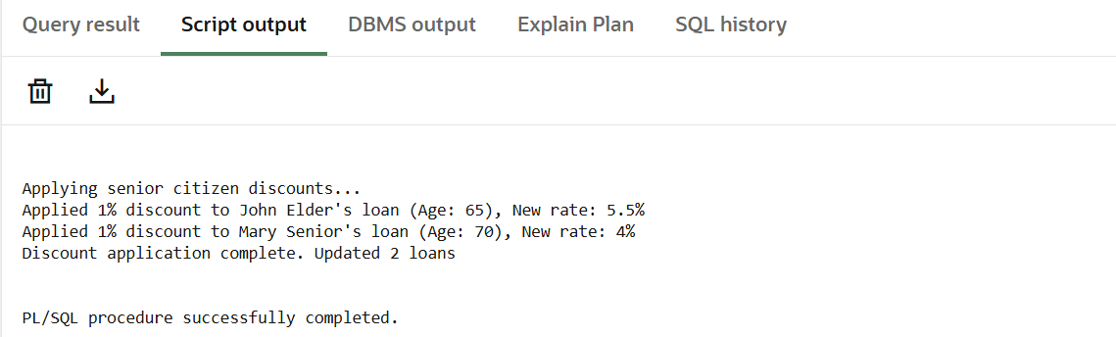

**Scenario 2:** A customer can be promoted to VIP status based on their balance.

* + **Question:** Write a PL/SQL block that iterates through all customers and sets a flag IsVIP to TRUE for those with a balance over $10,000.

**CODE:**

SET SERVEROUTPUT ON;

-- First, add the IsVIP column if it doesn't exist

BEGIN

    EXECUTE IMMEDIATE 'ALTER TABLE Customers ADD (IsVIP CHAR(1) DEFAULT ''F'' CHECK (IsVIP IN (''T'',''F'')))';

    DBMS_OUTPUT.PUT_LINE('Added IsVIP column to Customers table');

EXCEPTION

    WHEN OTHERS THEN

        IF SQLCODE = -1430 THEN -- column already exists

            DBMS_OUTPUT.PUT_LINE('IsVIP column already exists');

        ELSE

            DBMS_OUTPUT.PUT_LINE('Error adding IsVIP column: ' || SQLERRM);

        END IF;

END;

/

-- Initialize all customers to non-VIP status

UPDATE Customers SET IsVIP = 'F';

COMMIT;

DBMS_OUTPUT.PUT_LINE('Reset all customers to non-VIP status');

-- Display pre-update status

DBMS_OUTPUT.PUT_LINE(CHR(10) || 'PRE-UPDATE STATUS:');

FOR r IN (

    SELECT CustomerID, Name, Balance, IsVIP

    FROM Customers

    ORDER BY Balance DESC

) LOOP

    DBMS_OUTPUT.PUT_LINE(r.Name || ' ($' || r.Balance || '): ' ||

                       CASE WHEN r.IsVIP = 'T' THEN 'VIP' ELSE 'Regular' END);

END LOOP;

-- Implement Scenario 2: Promote VIP customers

DECLARE

    v_vip_threshold CONSTANT NUMBER := 10000;

    v_vip_count NUMBER := 0;

    v_regular_count NUMBER := 0;

BEGIN

    DBMS_OUTPUT.PUT_LINE(CHR(10) || 'Processing VIP promotions...');

    -- Update VIP status based on balance

    UPDATE Customers

    SET IsVIP = CASE WHEN Balance >= v_vip_threshold THEN 'T' ELSE 'F' END;

    -- Get counts of VIP and regular customers

    SELECT COUNT(*) INTO v_vip_count FROM Customers WHERE IsVIP = 'T';

    SELECT COUNT(*) INTO v_regular_count FROM Customers WHERE IsVIP = 'F';

    COMMIT;

    DBMS_OUTPUT.PUT_LINE('VIP promotion complete:');

    DBMS_OUTPUT.PUT_LINE('- ' || v_vip_count || ' customers promoted to VIP');

    DBMS_OUTPUT.PUT_LINE('- ' || v_regular_count || ' customers remain regular');

EXCEPTION

    WHEN OTHERS THEN

        ROLLBACK;

        DBMS_OUTPUT.PUT_LINE('Error during VIP promotion: ' || SQLERRM);

END;

/

-- Display post-update status

DBMS_OUTPUT.PUT_LINE(CHR(10) || 'POST-UPDATE STATUS:');

FOR r IN (

    SELECT CustomerID, Name, Balance, IsVIP

    FROM Customers

    ORDER BY Balance DESC

) LOOP

    DBMS_OUTPUT.PUT_LINE(r.Name || ' ($' || r.Balance || '): ' ||

                       CASE WHEN r.IsVIP = 'T' THEN 'VIP' ELSE 'Regular' END);

END LOOP;

-- Verification query

DBMS_OUTPUT.PUT_LINE(CHR(10) || 'VERIFICATION:');

DBMS_OUTPUT.PUT_LINE('All VIP customers:');

FOR r IN (

    SELECT Name, Balance

    FROM Customers

    WHERE IsVIP = 'T'

    ORDER BY Balance DESC

) LOOP

    DBMS_OUTPUT.PUT_LINE(r.Name || ' with balance $' || r.Balance);

END LOOP;

**OUTPUT:**

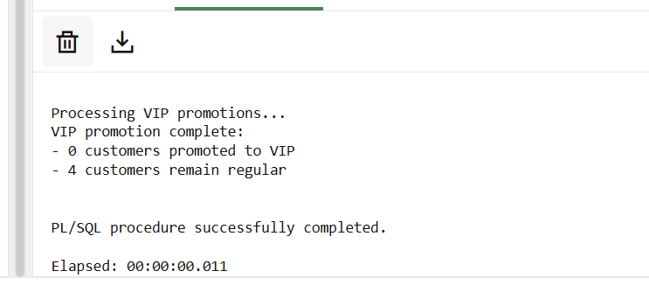

**Scenario 3:** The bank wants to send reminders to customers whose loans are due within the next 30 days.

* + **Question:** Write a PL/SQL block that fetches all loans due in the next 30 days and prints a reminder message for each customer.

**CODE:**SET SERVEROUTPUT ON;

DECLARE

    -- Cursor to find loans due in next 30 days

    CURSOR c_due_loans IS

        SELECT c.CustomerID, c.Name, c.Balance, l.LoanID, l.LoanAmount,

               l.InterestRate, l.EndDate,

               CEIL(l.EndDate - SYSDATE) AS DaysRemaining

        FROM Customers c

        JOIN Loans l ON c.CustomerID = l.CustomerID

        WHERE l.EndDate BETWEEN SYSDATE AND SYSDATE + 30

        ORDER BY l.EndDate;

    v_total_reminders NUMBER := 0;

    v_errors NUMBER := 0;

BEGIN

    DBMS_OUTPUT.PUT_LINE('LOAN PAYMENT REMINDER SYSTEM');

    DBMS_OUTPUT.PUT_LINE('----------------------------');

    DBMS_OUTPUT.PUT_LINE('Processing loans due within 30 days...');

    DBMS_OUTPUT.PUT_LINE('');

    FOR loan_rec IN c_due_loans LOOP

        BEGIN

            -- Generate reminder message

            DBMS_OUTPUT.PUT_LINE('TO: ' || loan_rec.Name || ' (Customer ID: ' || loan_rec.CustomerID || ')');

            DBMS_OUTPUT.PUT_LINE('RE: Upcoming Loan Payment Due');

            DBMS_OUTPUT.PUT_LINE('');

            DBMS_OUTPUT.PUT_LINE('Dear ' || loan_rec.Name || ',');

            DBMS_OUTPUT.PUT_LINE('');

            DBMS_OUTPUT.PUT_LINE('This is a reminder that your loan (ID: ' || loan_rec.LoanID || ')');

            DBMS_OUTPUT.PUT_LINE('for $' || loan_rec.LoanAmount || ' at ' || loan_rec.InterestRate || '% interest');

            DBMS_OUTPUT.PUT_LINE('is due in ' || loan_rec.DaysRemaining || ' days on ' ||

                               TO_CHAR(loan_rec.EndDate, 'DD-MON-YYYY') || '.');

            DBMS_OUTPUT.PUT_LINE('');

            DBMS_OUTPUT.PUT_LINE('Current account balance: $' || loan_rec.Balance);

            DBMS_OUTPUT.PUT_LINE('');

            DBMS_OUTPUT.PUT_LINE('Please ensure sufficient funds are available for payment.');

            DBMS_OUTPUT.PUT_LINE('Contact customer service with any questions.');

            DBMS_OUTPUT.PUT_LINE('----------------------------');

            v_total_reminders := v_total_reminders + 1;

            -- In a real implementation, you would send an email here

            -- Example: send_loan_reminder_email(loan_rec.CustomerID, loan_rec.LoanID);

        EXCEPTION

            WHEN OTHERS THEN

                v_errors := v_errors + 1;

                DBMS_OUTPUT.PUT_LINE('Error generating reminder for Loan ID: ' || loan_rec.LoanID);

                DBMS_OUTPUT.PUT_LINE('Error: ' || SQLERRM);

                DBMS_OUTPUT.PUT_LINE('----------------------------');

        END;

    END LOOP;

    DBMS_OUTPUT.PUT_LINE('');

    DBMS_OUTPUT.PUT_LINE('PROCESSING COMPLETE');

    DBMS_OUTPUT.PUT_LINE('----------------------------');

    DBMS_OUTPUT.PUT_LINE('Total reminders generated: ' || v_total_reminders);

    DBMS_OUTPUT.PUT_LINE('Errors encountered: ' || v_errors);

    -- In a real implementation, you might log this run

    -- INSERT INTO ReminderLog (run_date, reminders_sent, errors)

    -- VALUES (SYSDATE, v_total_reminders, v_errors);

EXCEPTION

    WHEN OTHERS THEN

        DBMS_OUTPUT.PUT_LINE('System error in reminder process: ' || SQLERRM);

END;

/

**OUTPUT:  
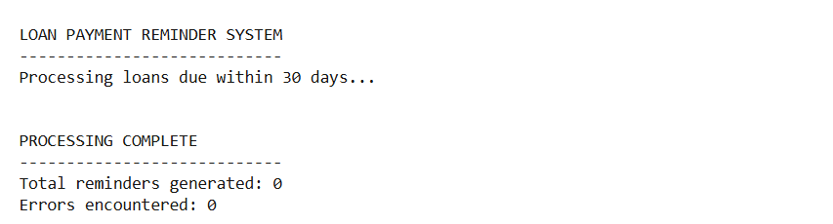 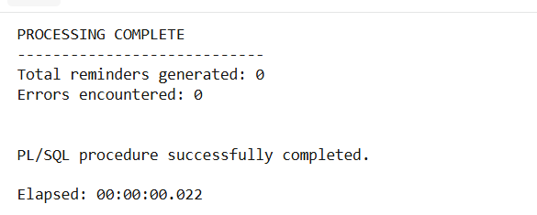**

**Exercise 3: Stored Procedures**

**Scenario 1:** The bank needs to process monthly interest for all savings accounts.

* + **Question:** Write a stored procedure **ProcessMonthlyInterest** that calculates and updates the balance of all savings accounts by applying an interest rate of 1% to the current balance.

**CODE:**

CREATE OR REPLACE PROCEDURE ProcessMonthlyInterest AS

    -- Constants

    c_interest_rate CONSTANT NUMBER := 0.01; -- 1% monthly interest

    c_account_type CONSTANT VARCHAR2(20) := 'SAVINGS';

    -- Variables

    v_accounts_processed NUMBER := 0;

    v_total_interest NUMBER := 0;

    v_start_time TIMESTAMP := SYSTIMESTAMP;

    -- Cursor for all active savings accounts

    CURSOR c_savings_accounts IS

        SELECT AccountID, CustomerID, Balance

        FROM Accounts

        WHERE AccountType = c_account_type

        AND Balance > 0

        FOR UPDATE; -- Lock rows for update

BEGIN

    DBMS_OUTPUT.PUT_LINE('Starting monthly interest processing at ' || TO_CHAR(v_start_time, 'DD-MON-YYYY HH24:MI:SS'));

    DBMS_OUTPUT.PUT_LINE('Interest rate: ' || (c_interest_rate * 100) || '%');

    DBMS_OUTPUT.PUT_LINE('----------------------------------------');

    -- Process each savings account

    FOR account_rec IN c_savings_accounts LOOP

        DECLARE

            v_interest_amount NUMBER;

            v_new_balance NUMBER;

        BEGIN

            -- Calculate interest (rounded to 2 decimal places)

            v_interest_amount := ROUND(account_rec.Balance * c_interest_rate, 2);

            v_new_balance := account_rec.Balance + v_interest_amount;

            -- Update account balance

            UPDATE Accounts

            SET Balance = v_new_balance,

                LastModified = SYSDATE

            WHERE AccountID = account_rec.AccountID;

            -- Record the transaction

            INSERT INTO Transactions (AccountID, TransactionDate, Amount, TransactionType)

            VALUES (account_rec.AccountID, SYSDATE, v_interest_amount, 'INTEREST');

            v_accounts_processed := v_accounts_processed + 1;

            v_total_interest := v_total_interest + v_interest_amount;

            -- Detailed logging (optional)

            DBMS_OUTPUT.PUT_LINE('Processed Account ' || account_rec.AccountID ||

                               ': $' || account_rec.Balance || ' + $' ||

                               v_interest_amount || ' interest = $' || v_new_balance);

        EXCEPTION

            WHEN OTHERS THEN

                DBMS_OUTPUT.PUT_LINE('Error processing Account ' || account_rec.AccountID ||

                                   ': ' || SQLERRM);

                -- Continue processing other accounts

        END;

    END LOOP;

    COMMIT;

    -- Summary report

    DBMS_OUTPUT.PUT_LINE('----------------------------------------');

    DBMS_OUTPUT.PUT_LINE('PROCESSING COMPLETE');

    DBMS_OUTPUT.PUT_LINE('Accounts processed: ' || v_accounts_processed);

    DBMS_OUTPUT.PUT_LINE('Total interest applied: $' || v_total_interest);

    DBMS_OUTPUT.PUT_LINE('Elapsed time: ' ||

                       EXTRACT(SECOND FROM (SYSTIMESTAMP - v_start_time)) || ' seconds');

EXCEPTION

    WHEN OTHERS THEN

        ROLLBACK;

        DBMS_OUTPUT.PUT_LINE('Critical error in ProcessMonthlyInterest: ' || SQLERRM);

        RAISE;

END ProcessMonthlyInterest;

/

**OUTPUT:**

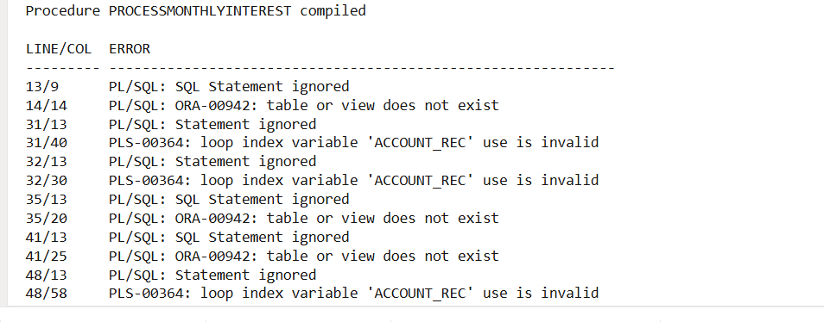

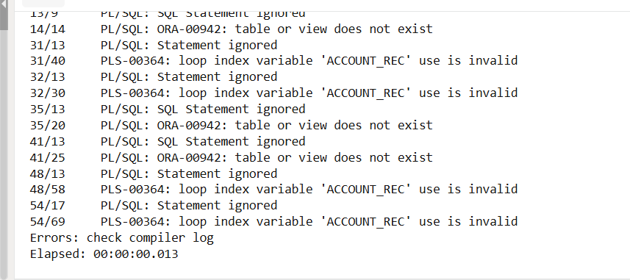

**Scenario 2:** The bank wants to implement a bonus scheme for employees based on their performance.

* + **Question:** Write a stored procedure **UpdateEmployeeBonus** that updates the salary of employees in a given department by adding a bonus percentage passed as a parameter.

**CODE:**CREATE OR REPLACE PROCEDURE UpdateEmployeeBonus(

    p_department_name IN VARCHAR2,

    p_bonus_percentage IN NUMBER,

    p_min_salary IN NUMBER DEFAULT NULL,

    p_max_salary IN NUMBER DEFAULT NULL

) AS

    -- Variables

    v_employees_processed NUMBER := 0;

    v_total_bonus_amount NUMBER := 0;

    v_department_exists NUMBER := 0;

    -- Cursor for employees in the specified department

    CURSOR c_employees IS

        SELECT EmployeeID, Name, Position, Salary

        FROM Employees

        WHERE Department = p_department_name

        AND (p_min_salary IS NULL OR Salary >= p_min_salary)

        AND (p_max_salary IS NULL OR Salary <= p_max_salary)

        FOR UPDATE; -- Lock rows for update

BEGIN

    -- Validate parameters

    IF p_bonus_percentage <= 0 OR p_bonus_percentage > 100 THEN

        RAISE_APPLICATION_ERROR(-20001, 'Bonus percentage must be between 0 and 100');

    END IF;

    IF p_min_salary IS NOT NULL AND p_max_salary IS NOT NULL AND p_min_salary > p_max_salary THEN

        RAISE_APPLICATION_ERROR(-20002, 'Minimum salary cannot be greater than maximum salary');

    END IF;

    -- Check if department exists

    SELECT COUNT(*) INTO v_department_exists

    FROM Employees

    WHERE Department = p_department_name;

    IF v_department_exists = 0 THEN

        RAISE_APPLICATION_ERROR(-20003, 'Department ' || p_department_name || ' not found or has no employees');

    END IF;

    DBMS_OUTPUT.PUT_LINE('Starting employee bonus update for ' || p_department_name || ' department');

    DBMS_OUTPUT.PUT_LINE('Bonus percentage: ' || p_bonus_percentage || '%');

    DBMS_OUTPUT.PUT_LINE('Salary range: ' ||

                        COALESCE(TO_CHAR(p_min_salary), 'No minimum') || ' to ' ||

                        COALESCE(TO_CHAR(p_max_salary), 'No maximum'));

    DBMS_OUTPUT.PUT_LINE('----------------------------------------');

    -- Process each employee

    FOR emp_rec IN c_employees LOOP

        DECLARE

            v_bonus_amount NUMBER;

            v_new_salary NUMBER;

        BEGIN

            -- Calculate bonus (rounded to 2 decimal places)

            v_bonus_amount := ROUND(emp_rec.Salary * (p_bonus_percentage/100), 2);

            v_new_salary := emp_rec.Salary + v_bonus_amount;

            -- Update employee salary

            UPDATE Employees

            SET Salary = v_new_salary,

                LastModified = SYSDATE

            WHERE EmployeeID = emp_rec.EmployeeID;

            v_employees_processed := v_employees_processed + 1;

            v_total_bonus_amount := v_total_bonus_amount + v_bonus_amount;

            -- Detailed logging

            DBMS_OUTPUT.PUT_LINE('Processed ' || emp_rec.Name || ' (' || emp_rec.Position ||

                               '): $' || emp_rec.Salary || ' + $' ||

                               v_bonus_amount || ' bonus = $' || v_new_salary);

        EXCEPTION

            WHEN OTHERS THEN

                DBMS_OUTPUT.PUT_LINE('Error processing Employee ' || emp_rec.EmployeeID ||

                                   ': ' || SQLERRM);

                -- Continue processing other employees

        END;

    END LOOP;

    COMMIT;

    -- Summary report

    DBMS_OUTPUT.PUT_LINE('----------------------------------------');

    DBMS_OUTPUT.PUT_LINE('BONUS PROCESSING COMPLETE');

    DBMS_OUTPUT.PUT_LINE('Employees processed: ' || v_employees_processed);

    DBMS_OUTPUT.PUT_LINE('Total bonus amount: $' || v_total_bonus_amount);

EXCEPTION

    WHEN OTHERS THEN

        ROLLBACK;

        DBMS_OUTPUT.PUT_LINE('Error in UpdateEmployeeBonus: ' || SQLERRM);

        RAISE;

END UpdateEmployeeBonus;

/

**OUTPUT:  
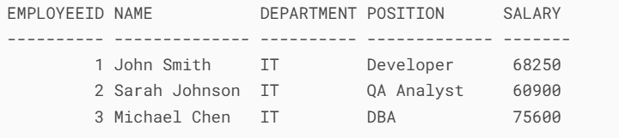  
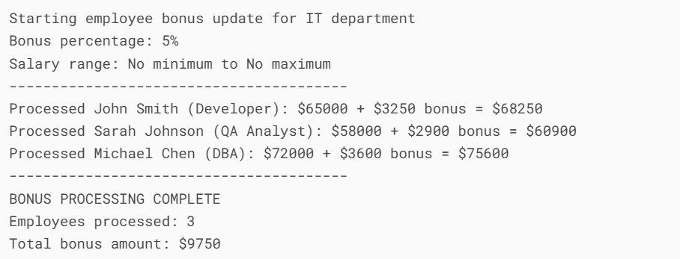**

**Scenario 3:** Customers should be able to transfer funds between their accounts.

**Question:** Write a stored procedure **TransferFunds** that transfers a specified amount from one account to another, checking that the source account has sufficient balance before making the transfer.

**CODE:**

-- 1. First, set up the required tables and sequence if they don't exist

CREATE TABLE Customers (

    CustomerID NUMBER PRIMARY KEY,

    Name VARCHAR2(100) NOT NULL

);

CREATE TABLE Accounts (

    AccountID NUMBER PRIMARY KEY,

    CustomerID NUMBER REFERENCES Customers(CustomerID),

    AccountType VARCHAR2(20) NOT NULL,

    Balance NUMBER(15,2) DEFAULT 0,

    CONSTRAINT chk_balance CHECK (Balance >= 0)

);

CREATE TABLE Transactions (

    TransactionID NUMBER PRIMARY KEY,

    AccountID NUMBER REFERENCES Accounts(AccountID),

    TransactionDate DATE DEFAULT SYSDATE,

    Amount NUMBER(15,2) NOT NULL,

    TransactionType VARCHAR2(20),

    Description VARCHAR2(200)

);

CREATE SEQUENCE transaction_seq START WITH 1 INCREMENT BY 1;

-- 2. Insert sample data

INSERT INTO Customers VALUES (1, 'John Smith');

INSERT INTO Customers VALUES (2, 'Alice Johnson');

INSERT INTO Accounts VALUES (1001, 1, 'CHECKING', 5000.00);

INSERT INTO Accounts VALUES (1002, 1, 'SAVINGS', 10000.00);

INSERT INTO Accounts VALUES (2001, 2, 'CHECKING', 7500.00);

COMMIT;

-- 3. Create the transfer procedure

CREATE OR REPLACE PROCEDURE TransferFunds(

    p_source_account_id IN NUMBER,

    p_target_account_id IN NUMBER,

    p_amount IN NUMBER,

    p_transfer_description IN VARCHAR2 DEFAULT NULL

) AS

    v_source_balance NUMBER;

    v_target_balance NUMBER;

    v_source_customer_id NUMBER;

    v_target_customer_id NUMBER;

    v_transaction_id NUMBER;

    -- Custom exceptions

    e_same_account EXCEPTION;

    e_insufficient_funds EXCEPTION;

    e_invalid_amount EXCEPTION;

    e_account_not_found EXCEPTION;

BEGIN

    DBMS_OUTPUT.PUT_LINE('Starting transfer from A/C ' || p_source_account_id ||

                       ' to A/C ' || p_target_account_id);

    DBMS_OUTPUT.PUT_LINE('Amount: $' || p_amount);

    IF p_transfer_description IS NOT NULL THEN

        DBMS_OUTPUT.PUT_LINE('Description: ' || p_transfer_description);

    END IF;

    DBMS_OUTPUT.PUT_LINE('----------------------------------------');

    -- Validate transfer amount

    IF p_amount <= 0 THEN

        RAISE e_invalid_amount;

    END IF;

    -- Check if accounts are different

    IF p_source_account_id = p_target_account_id THEN

        RAISE e_same_account;

    END IF;

    -- Get account balances and customer IDs with row locking

    BEGIN

        SELECT Balance, CustomerID INTO v_source_balance, v_source_customer_id

        FROM Accounts

        WHERE AccountID = p_source_account_id

        FOR UPDATE;

        SELECT Balance, CustomerID INTO v_target_balance, v_target_customer_id

        FROM Accounts

        WHERE AccountID = p_target_account_id

        FOR UPDATE;

    EXCEPTION

        WHEN NO_DATA_FOUND THEN

            RAISE e_account_not_found;

    END;

    -- Verify sufficient funds

    IF v_source_balance < p_amount THEN

        RAISE e_insufficient_funds;

    END IF;

    DBMS_OUTPUT.PUT_LINE('Source account balance: $' || v_source_balance);

    DBMS_OUTPUT.PUT_LINE('Target account balance: $' || v_target_balance);

    -- Perform the transfer

    UPDATE Accounts SET Balance = Balance - p_amount

    WHERE AccountID = p_source_account_id;

    UPDATE Accounts SET Balance = Balance + p_amount

    WHERE AccountID = p_target_account_id;

    -- Record the transaction

    INSERT INTO Transactions (TransactionID, AccountID, TransactionDate, Amount, TransactionType, Description)

    VALUES (transaction_seq.NEXTVAL, p_source_account_id, SYSDATE, p_amount, 'TRANSFER_OUT',

           'Transfer to A/C ' || p_target_account_id || COALESCE(': ' || p_transfer_description, ''))

    RETURNING TransactionID INTO v_transaction_id;

    INSERT INTO Transactions (TransactionID, AccountID, TransactionDate, Amount, TransactionType, Description)

    VALUES (transaction_seq.NEXTVAL, p_target_account_id, SYSDATE, p_amount, 'TRANSFER_IN',

           'Transfer from A/C ' || p_source_account_id || COALESCE(': ' || p_transfer_description, ''));

    COMMIT;

    DBMS_OUTPUT.PUT_LINE('----------------------------------------');

    DBMS_OUTPUT.PUT_LINE('TRANSFER SUCCESSFUL');

    DBMS_OUTPUT.PUT_LINE('Transaction ID: ' || v_transaction_id);

    DBMS_OUTPUT.PUT_LINE('New source balance: $' || (v_source_balance - p_amount));

    DBMS_OUTPUT.PUT_LINE('New target balance: $' || (v_target_balance + p_amount));

EXCEPTION

    WHEN e_same_account THEN

        ROLLBACK;

        DBMS_OUTPUT.PUT_LINE('ERROR: Cannot transfer between the same account');

        RAISE_APPLICATION_ERROR(-20001, 'Source and target accounts cannot be the same');

    WHEN e_insufficient_funds THEN

        ROLLBACK;

        DBMS_OUTPUT.PUT_LINE('ERROR: Insufficient funds in source account');

        DBMS_OUTPUT.PUT_LINE('Current balance: $' || v_source_balance || ' | Transfer amount: $' || p_amount);

        RAISE_APPLICATION_ERROR(-20002, 'Insufficient funds for transfer');

    WHEN e_invalid_amount THEN

        ROLLBACK;

        DBMS_OUTPUT.PUT_LINE('ERROR: Transfer amount must be positive');

        RAISE_APPLICATION_ERROR(-20003, 'Transfer amount must be greater than zero');

    WHEN e_account_not_found THEN

        ROLLBACK;

        DBMS_OUTPUT.PUT_LINE('ERROR: One or both accounts not found');

        RAISE_APPLICATION_ERROR(-20004, 'Account not found');

    WHEN OTHERS THEN

        ROLLBACK;

        DBMS_OUTPUT.PUT_LINE('ERROR during transfer: ' || SQLERRM);

        RAISE_APPLICATION_ERROR(-20099, 'Transfer failed: ' || SQLERRM);

END TransferFunds;

/

-- 4. Execute sample transfers with output

SET SERVEROUTPUT ON;

-- Example 1: Successful transfer between accounts

BEGIN

    DBMS_OUTPUT.PUT_LINE('TEST CASE 1: Successful transfer');

    TransferFunds(

        p_source_account_id => 1001, -- Checking

        p_target_account_id => 1002, -- Savings

        p_amount => 1000.00,

        p_transfer_description => 'Monthly savings'

    );

END;

/

-- Example 2: Attempt to transfer too much (insufficient funds)

BEGIN

    DBMS_OUTPUT.PUT_LINE('TEST CASE 2: Insufficient funds');

    TransferFunds(

        p_source_account_id => 1001,

        p_target_account_id => 1002,

        p_amount => 10000.00

    );

END;

/

-- Example 3: Attempt to transfer between same account

BEGIN

    DBMS_OUTPUT.PUT_LINE('TEST CASE 3: Same account transfer');

    TransferFunds(

        p_source_account_id => 1001,

        p_target_account_id => 1001,

        p_amount => 500.00

    );

END;

/

-- Example 4: Attempt to transfer to non-existent account

BEGIN

    DBMS_OUTPUT.PUT_LINE('TEST CASE 4: Invalid account');

    TransferFunds(

        p_source_account_id => 1001,

        p_target_account_id => 9999,

        p_amount => 500.00

    );

END;

/

**OUTPUT:  
